FACULTY PROFILE
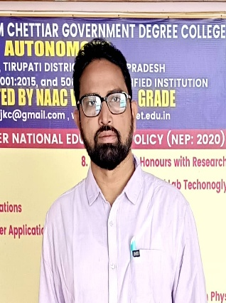

Name : SRINIVASA RAO ALLU
Designation : Lecturer in Commerce
Date of Birth : 15-08-1980.

Sex : Male

Marital Status : Married

Category : BC-D

Address for Communication : SVSSC Govt Degree College
Sullurpeta, Tirupathi Dist

Email ID : seenudevi1980@gmail.com
Phone No 9985377021

Educational Profile:

S.No | Course | Institute/University | Year of passing | percentage | Division
1 | B.Com | Andhra University Visakhapatnam | 2000 | 55% | Second  class
2 | M.Com | Andhra University Visakhapatnam | 2002 | 54% | Second  class
3 | AP SET  Commerce | Osmania University  Hyderabad | 2012
4 | B.Ed | SV University Tirupathi | 2006 | 56% | Second Class
5 | MA Lit.,  English | SV University Tirupathi | 2011 | 60% | First Class
6 | AP SET  English | Andhra University Visakhapatnam | 2019
Experience:

S.No | Period | years | College Name
1 | 2023 March- Till Date |  | SVSSC GDC, Sullurpet.

Declaration

I hereby declare that the information furnished above is true to the best of my knowledge.

Signature of the applicant (Srinivasa Rao Allu)

